**City University of Hong Kong**

2017-2018 Semester A

CS3343 Software Engineering Practice

**Project Plan**

Maverick:

The Smart Trading Platform

Group 14

|  |  |
| --- | --- |
| **Name** | **Student Number** |
| Dheeraj Khurana | 54227224 |
| Navwinder Singh | 54395023 |
| Ravinder Singh | 54390586 |
| Pang TSZ HO | 54387730 |
| Mathew Bilo | 54387858 |

**Our Project | Summary**

Description / what is our project about?

* Maverick is a smart trading system that helps users to do perform the following tasks:

1. Helps them to list their product on the maverick application portal
2. Help them to buy other products from the list of categories available
3. Helps to track user shopping history

What problem are we solving? | Purpose

The main idea behind the product was to have a trading platform for people in an intra organization (for example - students in CityU) so they can buy/sell things conveniently without needing to go outside of their campus/intra organization. Our projects helps the target audience in broadly 2 ways:

1. Convenience =>Save Time | Ease of Use

As our target project is an online system which can be used in an intra-organization, so it can really help people to easily access and buy/sell products without needing to travel a distance or hire an agency to deliver products. It can be easily used on different Operating system platforms, so it is also accessible to a wide audience.

1. History

Our application also keeps a track on your shopping purchases. Which will allow users to go through their order history and helps them to manage/keep a track on their personal expenses.

**Project Stakeholders**

|  |  |
| --- | --- |
| Stakeholders | Description |
| User - Buyer | Buyers can sign up into the application by choosing a password, ID. They are also required to input other information like their birthday date, premium membership details etc.  After signing up, they can start shopping by choosing from the list of categories of products and choosing the right price.  User-Buyer also gets the chance to track their shopping history by going to the history option. |
| User - Seller | Sellers can list/input their product into the respective categories.  Just like Buyers, Sellers are also required to sign up by choosing their respective ID, password etc. after only which they can process to list a product on application |
| Project Team Members | Responsible for the development of Maverick: The smart trading platform application |

**Our Project Team**

|  |  |  |
| --- | --- | --- |
| Name: | Designation: | Task Performed/Duties: |
| Dheeraj Khurana | Project Manager | Responsible for coordinating, managing and designing the backend computation for the product. Also helped in achieving the functional and non-functional requirements while also having test driven approach. |
| Navwinder Singh | Programmer | Responsible for programming the backend computation. Also helped in brainstorming, documentation and project management. |
| Ravinder Singh | Assistant Project Manager | Responsible for assisting the project manager in coordinating and doing testing work throughout the project. Also helped in Code refraction and bug testing reports |
| Pang TSZ HO | Testing Engineer | Duty includes performing different types of testing (Unit, integration, System) with other team mates. Also helped throughout the project in having a more test driven design approach for the programmer. Also, helped in documentation and making reports like bug reports, code refraction. |
| Mathew Bilo | Configuration Manager | Helped in the designing the complete structure of the application. Helped in completion of diagrams like use case, class and sequence diagrams |

**Tools Used**

1. Tools used for Development
   1. Eclipse Mars
2. Development Platform
   1. Windows 10/7 with Java Development Kit 1.8
3. Test Cases
   1. Junit 4
4. Coverage Checking
   1. EclEmma 2.0
5. Testing done on platforms
   1. Linux Ubuntu 16.04
   2. Mac OS
   3. Windows 7
   4. Windows 8.1
   5. Windows 10
6. Documentation
   1. for use case diagrams, class diagrams and sequence diagrams – **Visual Paradigm** has been used
   2. Java manual has been made using **Javadoc**
   3. **Bugzilla** is being used for recording bugs
   4. **Microsoft Word** for report
7. Project Management
   1. GitHub for development purposes
   2. Bitbucket
   3. Google Drive for resource sharing
   4. Microsoft PowerPoint
   5. Microsoft Word
   6. Snipping tool

# **Work Breakdown Structure (WBS)**

1. Project Research & Management
   1. Idea Gathering
2. Requirements Gathering
   1. Functional Requirements (Discounts, Reward Points, Shopping limitations)
   2. Non-functional Requirements (Recoverability, Robustness, Response Time, Stability)
3. Design and Analysis
   1. Setting up the structure with Diagrams (Use Case diagrams, Class, Sequence diagrams)
   2. Highlighting Patterns in the code (Singleton, Separation of Concerns, Law of Demeter etc.)
   3. Setting up the databases
4. Software Development
5. Testing
   1. Control Flow (Statement & Branch Coverage) & Predicate (Condition and Decision)
   2. Unit Testing
   3. Integration Testing
   4. System Testing
6. Bug Reports & Code Refactoring
7. Launch

**Future Prospects | what more to improve and add?**

For future developments we can work on the following categories to help user to get a more user friendly and better experience

1. Product Recommendation/Suggestions

In future, we can add a suggestion list of products for users which will be based on their search/buy history.

1. 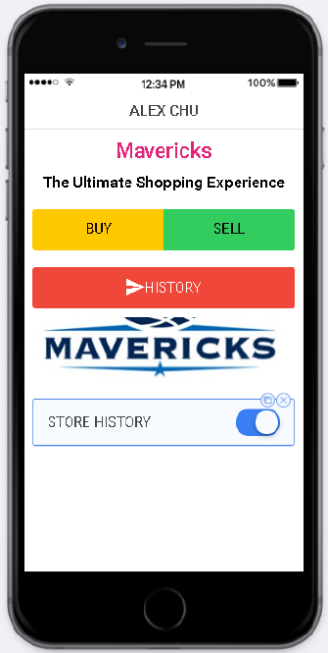Graphical User Interface(GUI)/Application

We plan on to have a better user interface and try to make the application readily available on mobile apps for android and iOS which will definitely help in user convenience. The prototype for the same has been shown below where you can see the basic function which have been implemented in the current program

1. Image based product search

Searching products by taking pictures and uploading them on to the application really helps users to find the product they see in real life conveniently.